Experiment No. 15
Implementation of Decision Tree Using Python
Question: Write a Python program to implement the Decision Tree algorithm for classification.
Aim: To implement a Decision Tree algorithm to classify data and predict an output based on given input features.
Algorithm:
- Start the program.
- Prepare the dataset with input features and output labels.
- Identify the input attributes and target class.
- Create a Decision Tree classifier.
- Train the classifier using the dataset.
- Accept new input values for prediction.
- Apply the decision rules to classify the input.
- Display the predicted output.
- Stop the program.
Code:
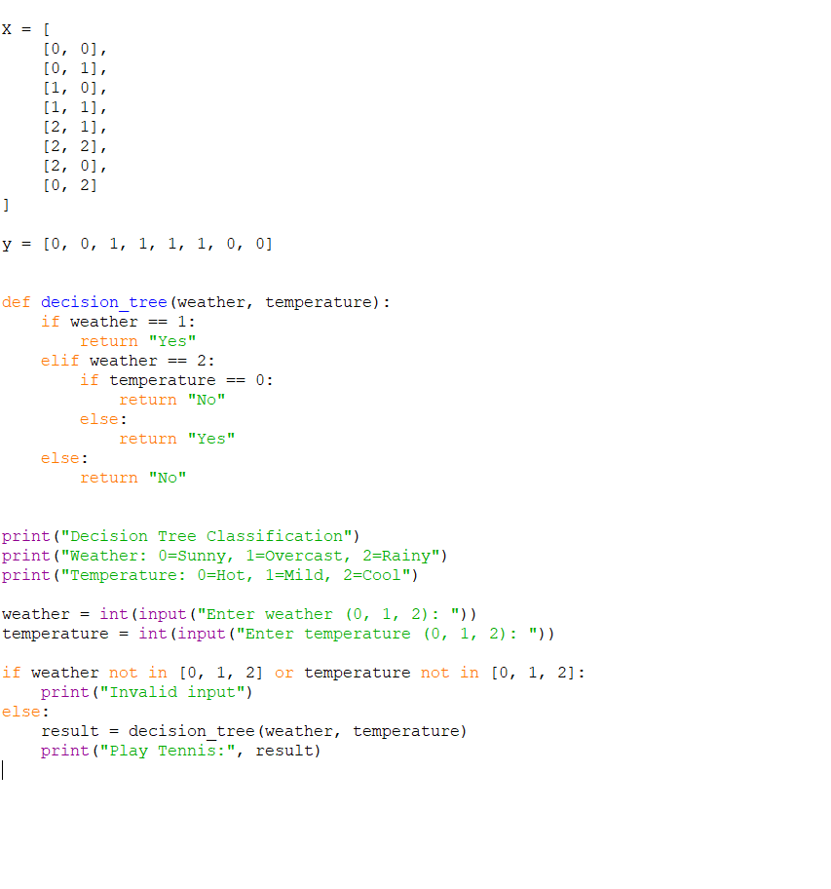
Output:

Result: The Decision Tree classification algorithm was successfully implemented using Python to predict the output based on the given input features.

